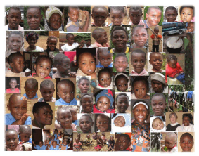
Good Shepherd Home for Children
Bamenda, Cameroon

I wish to sponsor a child for $40.00 per month

My Name: ________________________________________________________________________________
My Address: ________________________________________________________________________________
________________________________________________________________________________
________________________________________________________________________________
My phone number: ________________________________________________________________________________
My email address: ________________________________________________________________________________

__________ Enclosed is my donation for ____________ months.

__________ I would like to be billed monthly, quarterly, semi-annually, or annually
(please circle your choice)

Signed: ___________________________________________________________ Date:________________________________________

Please make check payable to:
Community of St. John Baptist
Attn: Maureen Woods
P.O. Box 240
Mendham, NJ 07945

